First Ancient DNA from West Africa Illuminates the Deep Human Past

An interdisciplinary study on ancient DNA from west-central Africa will appear in Nature on January 22.

- The study examines DNA from four people buried in the Shum Laka rockshelter in Cameroon, about 8,000 years ago and 3,000 years ago, at the transition from the Stone to Iron Ages. This study reports the first ancient DNA recovered from West or Central Africa, and includes some of the oldest DNA recovered from the African tropics.

- This part of west-central Africa – the ‘Grassfields’ region of Cameroon – has been identified as the probable cradle of Bantu languages, the most widespread and diverse group of languages in Africa today. For decades, linguists, archaeologists, and geneticists have investigated the origin of Bantu languages and their spread after ~4,000 years ago.

- None of the sampled individuals from Shum Laka are closely related to most present-day Bantu-speakers. Instead, they were part of a separate population that lived in the region for at least five millennia, and was later almost completely replaced by very different populations whose descendants comprise the majority of people living in Cameroon today.

- The Shum Laka individuals harbored about two-thirds of their ancestry from a previously unknown lineage distantly related to present-day West Africans and about one-third of their ancestry from a lineage related to present-day central African hunter-gatherers. This finding reveals previously unknown genetic diversity prior to the spread of food production.

- Analysis of whole-genome ancient DNA data from these individuals provided insights into the relationships among several early-branching African human lineages. Results suggest that lineages leading to today’s central African hunter-gatherers, southern African hunter-gatherers, and all other modern humans diverged in close succession about 250,000-200,000 years ago.

- Another set of genetic divergences was identified dating to about 80,000-60,000 years ago, including the lineage leading to all present-day non-Africans.

- These findings strengthen arguments recently made by archaeologists and geneticists that human origins in Africa may have involved deeply divergent, geographically separated populations.

Africa is the homeland of our species – Homo sapiens – and harbors greater human genetic diversity than any other part of the planet. Studies of ancient DNA from African archaeological sites can thus shed important light on the deep origins of humankind. However, ancient DNA studies from Africa remain few in number, in part due to the challenges of extracting DNA from degraded skeletons in tropical contexts.

An international research team led by Harvard Medical School scientists has sequenced DNA from four children buried 8,000 and 3,000 years ago at the iconic archaeological site of Shum Laka in Cameroon, excavated by a Belgian and Cameroonian team around thirty years ago. The findings, published January 22 in Nature, represent the first ancient DNA from West or Central Africa, and some of the oldest DNA recovered from an African tropical context. They enable a new understanding of the deep ancestral relationships among early Homo sapiens in sub-Saharan Africa.

A unique archaeological site with exceptional preservation
Shum Laka is a rockshelter located in the ‘Grassfields’ region of Cameroon, a place long pinpointed by linguists as the probable cradle of Bantu languages, a widespread and diverse group of languages spoken by more than a third of Africans today. “Linguists, archaeologists, and geneticists have been studying the origin and spread of Bantu languages for decades, and the Grassfields region is key to this question,” says Dr. Mary Prendergast of Saint Louis University, a co-supervising author of the study. The consensus is that the Bantu language group originated in west-central Africa, before spreading across the southern half of the continent after about 4,000 years ago. This expansion is thought to be the reason why the majority of people from central, eastern and southern Africa are genetically closely related to each other and to West Africans.

“Shum Laka is a reference point for understanding the deep history of west-central Africa,” says Dr. Isabelle Ribot, a University of Montreal anthropologist who excavated and studied the burials, and is a key author of the study. The Shum Laka rockshelter was excavated in the 1980s and 1990s by archaeologists from Belgium and Cameroon. It boasts an impressive and well-dated archaeological record, with radiocarbon dates spanning the past 30,000 years. Stone tools, plant and animal remains, and eventually pottery collectively indicate long-term forest-based hunting and gathering and an eventual transition to intensive tree fruit exploitation.

Shum Laka is emblematic of the ‘Stone to Metal Age,’ a critical era in west-central African history that ultimately gave rise to Iron Age metallurgy and farming. During this era, the site repeatedly served as a burial ground for families, with 18 individuals (mainly children) buried in two major phases at about 8,000 and 3,000 years ago. “Such burials are unique for West and Central Africa,” says Ribot, “because human skeletons are exceedingly rare here prior to the Iron Age. Tropical environments and acidic soils are not kind to bone preservation, so the results from our study are really remarkable.”

Scientists at Harvard Medical School sampled petrous (inner-ear) bones from six individuals buried at Shum Laka. Four of these samples produced ancient DNA, and were directly dated at the Pennsylvania State University Radiocarbon Laboratory. The molecular preservation was impressive given the burial conditions, and enabled whole-genome ancient DNA analysis.

A newly documented population of hunter-gatherers
Surprisingly, the ancient DNA sequenced from the four children – one pair buried 8,000 years ago, the other 3,000 years ago – reveals ancestry very different from that of most Bantu-speakers today. Instead, they are more similar to central African hunter-gatherers. “This result suggests that Bantu-speakers living in Cameroon and across Africa today do not descend from the population to which the Shum Laka children belonged,” says Dr. Mark Lipson of Harvard Medical School, lead author of the study. “This underscores the ancient genetic diversity in this region,” he continues, “and points to a previously unknown population that contributed only small proportions of DNA to present-day African groups.”

The spreads of farming and herding in Africa – as in other parts of the world – were accompanied by many movements of people. “If you go back 5,000 years ago, virtually everyone living south of the Sahara was a hunter-gatherer,” says Prendergast, “but look at a map of Africa showing foraging groups today, and you’ll see they are very few and far between.” This study contributes to a growing body of ancient DNA research demonstrating ancient genetic diversity and population structure that has since been erased by the demographic changes that accompanied the spread of food production.

A rare paternally inherited lineage with deep roots
One of the sampled individuals – an adolescent male – carried a rare Y chromosome haplogroup (A00) found almost nowhere outside western Cameroon today. A00 is best documented among the Mbo and Bangwa ethnic groups living not far from Shum Laka, and this is the first time it has been seen in ancient DNA. A00 is a deeply divergent haplogroup, having split from all other known human lineages about 300,000-200,000 years ago. This shows that this oldest known lineage of modern human males has been present in west-central Africa for more than 8,000 years, and perhaps much longer.

New light on human origins
While the findings do not speak directly to Bantu language origins, they do shed new light on multiple phases of the deep history of Homo sapiens. The researchers examined the DNA of the Shum Laka children alongside published DNA from ancient hunter-gatherers from eastern and southern Africa, as well as DNA from many present-day African groups. Combining these datasets, they were able to construct a model of diverging lineages over the course of the human past.

“Our analysis indicates the existence of at least four major deep human lineages that contributed to people living today, and which diverged from each other between about 250,000 and 200,000 years ago,” says Dr. David Reich of Harvard Medical School, senior author of the study. These lineages are ancestral to present-day central African hunter-gatherers, southern African hunter-gatherers, and all other modern humans, with a fourth lineage being a previously unknown ‘ghost population’ that contributed a small amount of ancestry to both western and eastern Africans. “This quadruple radiation—including the position of a deeply-splitting ‘ghost’ modern human lineage—had not been identified before from DNA,” Reich continues.

Previous models for human origins suggested that present-day southern African hunter-gatherers, who split from other populations about 250,000–200,000 years ago, represent the deepest known branch of modern human variation. However, according to Lipson, “the new analysis suggests that the lineage contributing to central African hunter-gatherers is similarly ancient and diverged from other African populations around the same time.” This finding adds to a growing consensus among archaeologists and geneticists that human origins in Africa may have involved deeply divergent, geographically separated populations.

Analysis also revealed another set of four human lineages branching between 80,000 and 60,000 years ago, including the lineages contributing the majority of the ancestry in present-day eastern and western Africans and all non-Africans.

In light of this new model of human population relationships, the authors were able to show that about one third of the ancestry of the Shum Laka children derived from a lineage closely related to central African hunter-gatherers, and about two thirds of their ancestry came from a distinctive lineage distantly related to the majority of present-day West Africans.

Says Reich: “These results highlight how the human landscape in Africa just a few thousand years ago was profoundly different from what it is today, and emphasize the power of ancient DNA to lift the veil over the human past that has been cast by recent population movements.”

An international collaboration
This study was the product of collaboration among geneticists, archaeologists, biological anthropologists, and museum curators based in North America (including Harvard Medical School and the Université de Montréal), Europe (Royal Belgian Museum of Natural Sciences, Royal Museum for Central Africa, Université Libre de Bruxelles, and Saint Louis University’s Madrid campus), Cameroon (University of Yaoundé, University of Buea), and China (Duke Kunshan University) among others.

“Interdisciplinary collaborations like this one are an essential part of ancient DNA research,” says Reich. This study underscores the importance of examining older museum collections with fresh methods, as four individuals from a single site have enabled extensive insights into human population history. Researchers plan to return to the site of Shum Laka this year, in part to help communicate findings to the Cameroonian academic and broader communities.

Publication information
Title: Ancient West African foragers in the context of African population history
Publication: Nature. DOI: 10.1038/s41586-020-1929-1
Authors: Mark Lipson*, Isabelle Ribot, Swapan Mallick, Nadin Rohland, Iñigo Olalde, Nicole Adamski, Nasreen Broomandkhoshbacht, Ann Marie Lawson, Saioa López, Jonas Oppenheimer, Kristin Stewardson, Raymond Neba’ane Asombang, Hervé Bocherens, Neil Bradman, Brendan J. Culleton, Els Cornelissen, Isabelle Crevecoeur, Pierre de Maret, Forka Leypey Mathew Fomine, Philippe Lavachery, Christophe Mbida Mindzie, Rosine Orban, Elizabeth Sawchuk, Patrick Semal, Mark G. Thomas, Wim Van Neer, Krishna R. Veeramah, Douglas J. Kennett, Nick Patterson, Garrett Hellenthal, Carles Lalueza-Fox, Scott MacEachern, Mary E. Prendergast+ & David Reich+
*Corresponding author
+Co-supervising author

Media Contacts:
Mark Lipson
Harvard Medical School Department of Genetics
Email: mark.lipson@gmail.com

Isabelle Ribot
Université de Montréal
Email: i.ribot@umontreal.ca

Mary Prendergast
Saint Louis University (Madrid)
Email: mary.prendergast@slu.edu

David Reich
Harvard Medical School Department of Genetics
Email: reich@genetics.med.harvard.edu

Images:
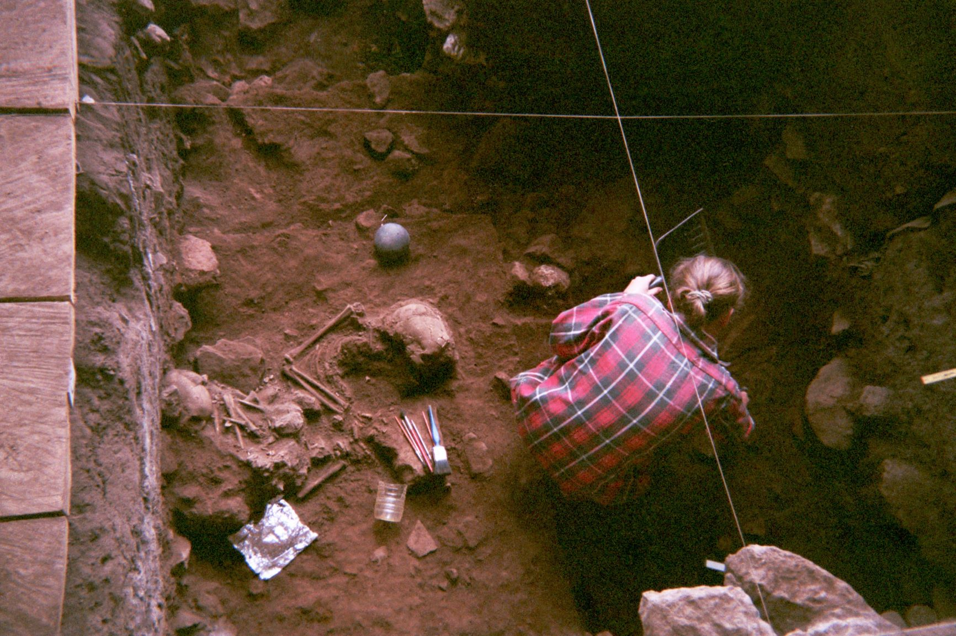

Image 1: Excavation of a double burial at Shum Laka Rockshelter in Cameroon, containing the remains of two boys who lived ~8000 years ago and who were genetically from the same family. Ancient DNA reveals that these two individuals and another pair of children buried five millennia later at Shum Laka were from a stable population that was then almost completely replaced by the very different populations living in Cameroon today (photo by Isabelle Ribot, January 1994).

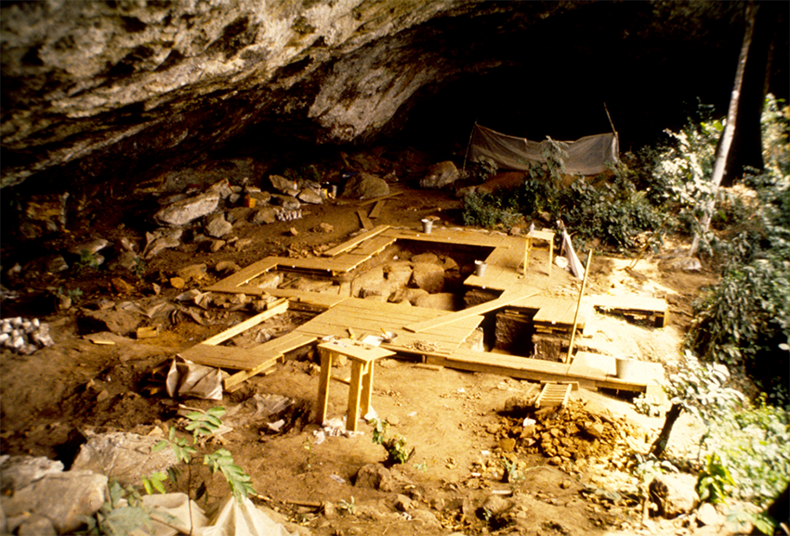

Image 2: General view of the excavation of Shum Laka Rockshelter in Cameroon. This site was home to a human population that lived in the region for at least five millennia and bore little genetic relatedness to the people who live in the region today. Analysis of whole-genome ancient DNA data from four people who lived at this site provided insights into the relationships among several early-branching African human lineages (photo by Pierre de Maret, January 1994).

