First Ancient DNA from West/Central Africa Illuminates Deep Human Past

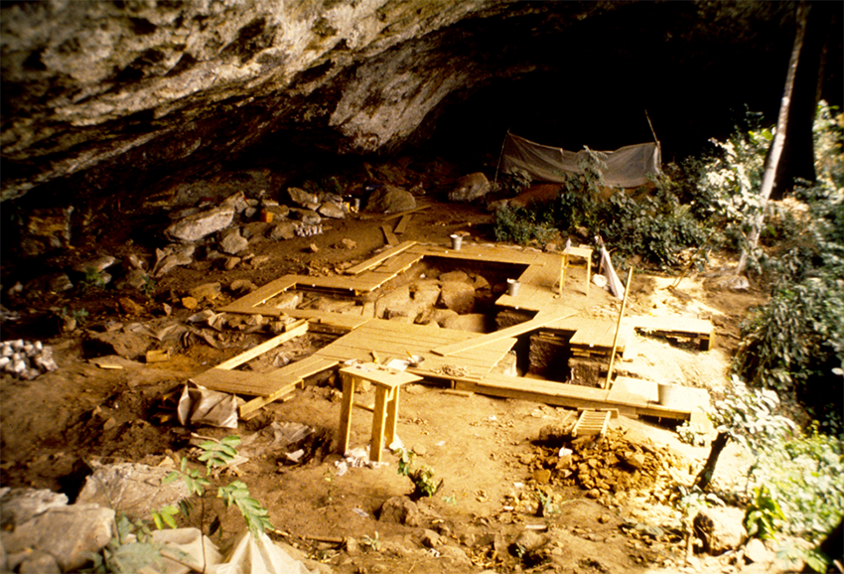
The Shum Laka rock shelter in Cameroon, home to an ancient population that bears little genetic resemblance to most people who live in the region today. Image: Pierre de Maret

An international team led by Harvard Medical School scientists has produced the first genome-wide ancient human DNA sequences from west and central Africa.

The data, recovered from four individuals buried at an iconic archaeological site in Cameroon between 3,000 and 8,000 years ago, enhance our understanding of the deep ancestral relationships among populations in sub-Saharan Africa, which remains the region of greatest human diversity today.

The findings, published Jan. 22 in Nature, provide new clues in the search to identify the populations that first spoke and spread Bantu languages. The work also illuminates previously unknown “ghost” populations that contributed small portions of DNA to present-day African groups.

Research highlights:

- DNA came from the remains of two pairs of children who lived around 3,000 years ago and 8,000 years ago, respectively, during the transition from the Stone Age to the Iron Age.
- The children were buried at Shum Laka, a rock shelter in the Grassfields region of northwestern Cameroon where ancient people lived for tens of thousands of years. The site has yielded prolific artifacts along with 18 human skeletons and lies in the region where researchers suspect Bantu languages and cultures originated. The spread of Bantu languages—and the groups that spoke them—over the past 4,000 years is thought to explain why the majority of people from central, eastern and southern Africa are closely related to one another and to west/central Africans.
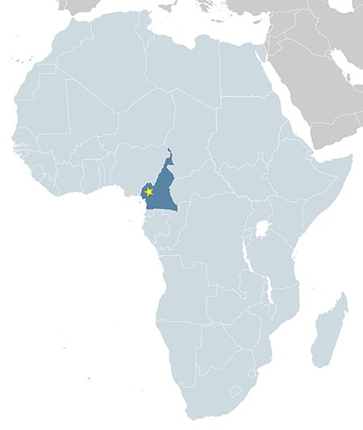
Map of Africa with Cameroon in dark blue and approximate location of Shum Laka marked with star. Image adapted from Alvaro1984 18/Wikimedia Commons

- Surprisingly, all four individuals are most closely related to present-day central African hunter-gatherers, who have very different ancestry from most Bantu speakers. This suggests that present-day Bantu speakers in western Cameroon and across Africa did not descend from the sequenced children’s population.
- One individual’s genome includes the earliest-diverging Y chromosome type, found almost nowhere outside western Cameroon today. The findings show that this oldest lineage of modern human males has been present in that region for more than 8,000 years, and perhaps much longer.
- Genetic analyses indicate that there were at least four major lineages deep in human history, between 200,000 and 300,000 years ago. This branching hadn’t been identified previously from genetic data.
- Contrary to common models, the data suggest that central African hunter-gatherers diverged from other African populations around the same time as southern African hunter-gatherers did.
- Analyses reveal another set of four branching human lineages between 60,000 and 80,000 years ago, including the lineage known to have given rise to all present-day non-Africans.
- The Shum Laka individuals themselves harbor ancestry from multiple deep lineages, including a previously unknown, early-diverging ancestry source in West Africa.
Paper: Mark Lipson, et al., “Ancient West African foragers in the context of African population history,” Nature, DOI 10.1038/s41586-020-1929-1

